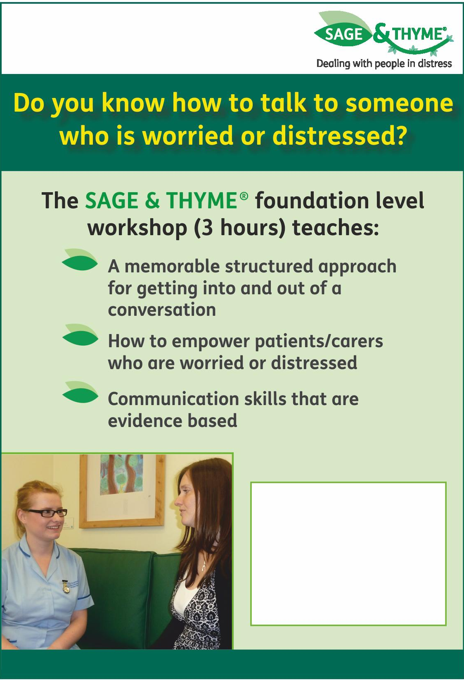
Date | Time | Venue
2019
Monday 16th September | 9.30-12.30pm | Sobell House, Churchill  Hospital, Oxford
Tuesday 15th October | 9.30-12.30pm | Katharine House Hospice, Banbury
2020
Thursday 13th February | 1-4pm | John Radcliffe Hospital, Oxford
Thursday 2nd April | 9.30-12.30pm | Sobell House, Churchill  Hospital, Oxford

Please book online £35 per person
www.sobelleducation.org.uk/courses

Registration Form

Communication skills training for professionals
Sage and ThymeTM

Date of preferred session:

Surname |  | First Name
Job Title |  |  | Mr/Mrs/Ms/Dr
Organisation where you work
Address where you work |  |  | Invoice details
Postcode
Telephone | Work: |  | Email:
Email |  |  | Cheques payable to ‘OxCERPC’  Card payments: 01865 225889

Where did you hear about this course? (tick as appropriate)

Flyer Recommendation Sobell House Website Other website E-mail

Signed …… ………………………………….. Date ……………….

Please send completed forms to:

OxCERPC: Sobell House
Churchill Hospital
Oxford
OX3 7LE

Email: ssc@ouh.nhs.uk

