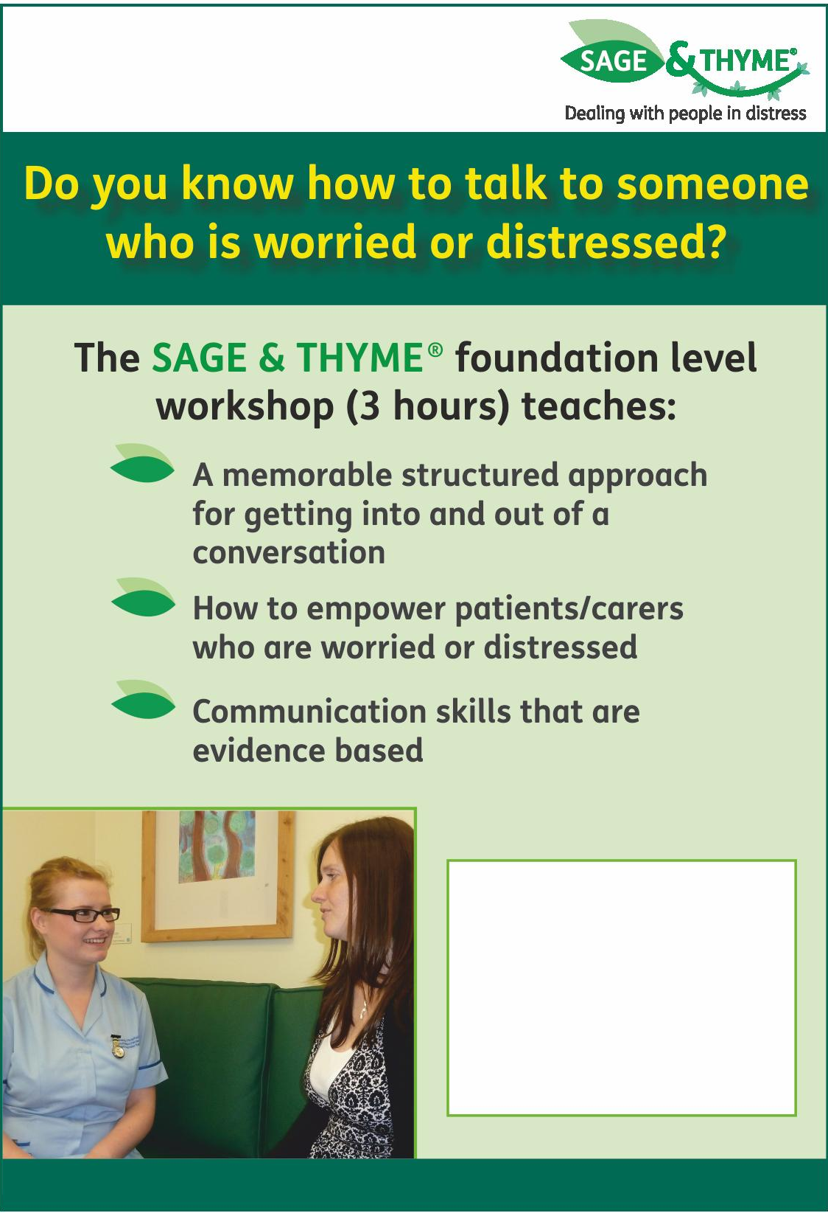
Date | Time | Venue
2018
Tuesday 26th June | 9.30-12.30pm | Katharine House Hospice, Banbury
Friday 14th September | 1-4pm | John Radcliffe Hospital, Oxford
Tuesday 9th October | 9.30-12.30pm | Sobell House, Churchill  Hospital, Oxford
Wednesday 19 December | 1-4pm | John Radcliffe Hospital, Oxford
2019
Tuesday 12th February | 9.30-12.30pm | Sobell House, Churchill  Hospital, Oxford
Thursday 4th April | 1-4pm | John Radcliffe Hospital, Oxford

This course and all supporting literature is free of charge.

Please note there will be a £30 charge for non attendance.
For application forms: email: ssc@ouh.nhs.uk

Registration Form

Communication skills training for professionals
Sage and ThymeTM

Date of preferred session:

Please note there will be a £30 charge for non-attendance

Surname |  | First Name
Job Title |  |  | Mr/Mrs/Ms/Dr
Organisation where you work
Address where you work |  |  | Preferred address for correspondence  (if different)
Postcode
Telephone | Work:
Email |  |  | Fax

Where did you hear about this course? (tick as appropriate)

Flyer Recommendation Sobell House Website Other website E-mail

Signed …… ………………………………….. Date ……………….

Please send completed forms to:
Karen Allen, Sobell Study Centre,
Sobell House, Churchill Hospital,
Oxford, OX3 7LE

Email: ssc@ouh.nhs.uk

